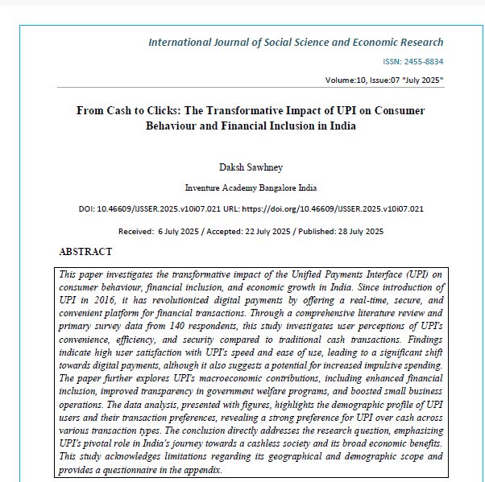
Overview:
- The paper further explores UPI's macroeconomic contributions, including enhanced financial inclusion, improved transparency in government welfare programs, and boosted small business operations.
- The data analysis, presented with figures, highlights the demographic profile of UPI users and their transaction preferences, revealing a strong preference for UPI over cash across various transaction types.
- The paper addresses the research question, emphasizing UPI's pivotal role in India's journey towards a cashless society and its broad economic benefits.

